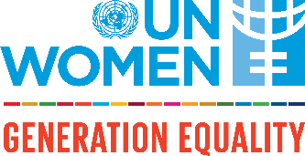
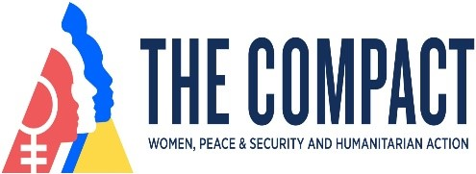

Reinforcing Women, Peace and Security in ECA region – how COMPACT on WPS-Humanitarian Action can translate commitments into results

Regional Roundtable

Date: 1 September 2022
Time: 14:00 –16:30 Istanbul time
Registration link
Event webpage
Language: English, Russian (simultaneous translation)

BACKGROUND

The Compact WPS-HA, launched at the Generation Equality Forum in France in July 2021 is a five-year push for gender equality with an intention to reshape peace and security and humanitarian action processes to systematically include women and girls in the decisions that impact their lives. The Compact is an inter-generational, inclusive movement for action on WPS and gender equality in humanitarian action. The WPS-HA Compact calls for the redesign of peace and security and humanitarian processes to include women and girls systematically and meaningfully, including peace-builders, refugees, other forcibly displaced and stateless women and girls, in the decisions that impact their lives.
The Compact has 5 thematic areas: financing the WPS agenda and gender equality in humanitarian programming, women’s meaningful participation in peace processes, women’s economic security, access to resources and other essential services, women’s leadership and agency across peace, security and humanitarian actors and protection of women in conflict and crisis contexts, including women human rights defenders. A series of specific actions to which Compact Signatories can sign up for support the achievement of results in all 5 issues areas.
In Europe and Central Asia, there are currently 48 signatories out of all 160 signatories globally (30%). The signatories are various actors including members states, Civil Society Organizations, academic institutions, UN entities, and regional organizations such as Organization for Security and Cooperation in Europe (OSCE).
Many more civil society partners, activists and some state officials have shown their interest in becoming the signatories of the Compact in order to leverage the platform in showcasing concrete commitments on WPS and Gender Equality in Humanitarian Action for collective actions and advocacy to accelerate the change and to spotlight gender equality in peace, security and humanitarian sector globally.
OBJECTIVE
The UN Women Europe and Central Asia Regional Office is organizing a Regional Platform with partners to exchange on how to channel their commitments and resources to address WPS-HA gaps in the region.
The platform provides a space for partners who have signed the Compact to share their experiences, showcase results achieved and ‘what works’ now after one year into the Compact. Joined by also other partners, the platform is an opportunity to explore new and joint commitments to promote women’s participation in peace and security initiatives and humanitarian programming in the region.
The event will bring together member states, Civil Society, youth networks, think-thanks, academia, International and regional organizations for an open and inclusive dialogue.

AGENDA
14:00 – 14:10 Welcoming and opening remarks

Ms. Alia El-Yassir, UN Women Regional Director for Europe and Central Asia

14:10 – 14:30 Overview of the WPS-Humanitarian Action Compact by UN Women – how it is expected to strengthen accountability for WPS-HA

Keynote by Ms. Harriette Williams Bright, UN Women Policy Specialist/Peace and Security

Q&A

14:30 – 15:05 Voices of the signatories on WPS-HA Compact – panel discussion:

- Key three achievements in implementing commitments of the WPS-HA Compact in 2021
- What works and what doesn’t work in terms of translating commitments into actions and sustaining the results

Ms. Florence Waller Car, Our Generation for Inclusive Peace (OGIP)

Ms. Katri Viinikka – Government of Finland

Ms. Toni Haastrup, University of Stirling, UK

Ms. Mariana Groba Gromes, Organization for Security and Co-operation in Europe (OSCE)

Mr. Francesco Marrella - OSCE Office for Democratic Institutions and Human Rights

Q&A. Short reflections from the floor.

15:05 – 15:55 Inclusion and Leadership - gaps and solutions for efficient implementation of WPS-HA Compact actions

Moderator - Ekaterine Gamakharia, Cultural-Humanitarian Fund “Sukhumi”, Georgia

Plenary discussions:
- Avenues and priorities for strengthened women’s leadership to mobilize for joint actions and sustained results
Ms. Edita Tahiri, Regional Women’s Lobby in South East Europe

- Strengthening peace-building and humanitarian work through increased engagement with young leaders
Mr. Ulugbek Nurunbetov, Institute for Peace and Development/Kyrgyzstan

- Enhancing partners’ collaboration and engagement with non-traditional actors
Ms. Valentina Bodrug, Gender-Centru/Moldova

Reflections from the floor.

Moderated discussion:

- What are the priority actions to accelerate the implementation of WPS-HA commitments in the region, addressing both long-standing and emerging challenges?

- What could be done together through LNOB and intergenerational approaches?

15:55 – 16:00 Wrap-up and key take aways

