Clarification No 1 to the Call for Proposals for Responsible Parties within the scope of ‘Strengthening civil society capacities and multi-stakeholder partnerships to advance women’s rights and gender equality in Turkey’ launched on 4 April 2022 with the deadline 17 June 2022 Turkey midnight time
CFP No. CFP – TUR – 2022 – 01
Issue date of the clarifications: 22 April 2022
This clarification aims to notify the potential proponents regarding the forms to be used when submitting the applications and to respond to the queries received by 19 April 2022. A second clarification will be issued in May 2022 to respond further queries sent to turkey.procurement@unwomen.org until 11 May 2022.
- Please note that the Template for the Call for Proposals CFP NO. CFP – TUR – 2022 – 01 issued on 4 April 2022 has been modified.

The modification has been made in the Annex B-2 Template for proposal submission in the Section entitled Component 1. Organizational Background and Capacity to implement activities to achieve planned results on page 21. Please note that there are additional questions in this section, indicated below and highlighted in yellow with regards to organizational measures on sexual exploitation and abuse (SEA). Please ensure to download the latest version at the https://eca.unwomen.org/en/stories/news/2022/04/call-for-proposals-strengthening-civil-society-capacities-and-multi-stakeholder-partnerships-to-advance-womens-rights-and-gender-equality-in-turkey and fill in the details under question 7 in your application document. (See below)

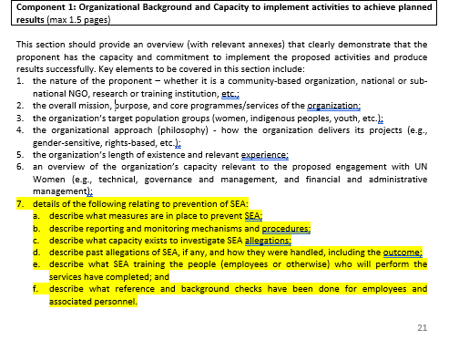
Clarifications in response to questions received:
Query 1: What is the purpose of the Call for Proposals?
Answer 1: A Call for Proposal for Responsible Parties is an invitation for a partnership engagement with UN Women to support programme implementation, to provide services using the programme budget and manage the use of these goods and/or services to carry out planned activities and produce outputs. Applicant CSOs are expected to have sufficient organizational, administrative, and financial capacity to implement programs. The proposed program, on the other hand, are expected to produce effective results in the field.
Query 2: Who are eligible to apply to the Call for Proposals?
- Are women-led initiatives or platforms eligible to apply to Call for Proposals?
- Are universities eligible to apply to the Call for Proposals?
- Are international non-governmental organizations eligible to apply to the Call for Proposals?
- Are municipalities eligible to apply to the Call for Proposals?
- Are cooperatives eligible to apply to the Call for Proposals?
- Are not-for-profit companies eligible to apply to the Call for Proposals?
- Are individuals or individual academics, activists eligible to apply to the Call for Proposals?
- Are newly founded women’s organizations eligible to apply to Call for Proposals?
Answer 2: The applicants must be civil society organizations, i.e. associations or foundations legally established and operating in Turkey. Initiatives or platforms that do not have a legal entity/official registration are not eligible to apply under this Call for Proposals. International non-governmental organizations that do not have a legal entity/official registration in Turkey are not eligible to apply under this Call for Proposals. Municipalities, cooperatives, international organizations, companies, private or public universities or individuals are not eligible applicants under this Call for Proposals.
UN Women will prioritize applications from women’s rights and women-led organizations, except for lot 4. For lot 4, the applicants must be youth civil society organizations managed and led by youth and serve primarily the interests of youth, i.e. youth-led and youth-focused, which must be evidenced by their statutes or official organizational mission and vision statements.
The applicants as an organization must have been in operation for at least five (5) years as of 17 June 2022, which is the deadline for applications to this Call for Proposals. In exceptional circumstances three (3) years of history registration may be accepted and it must be fully justified. These provisions will be strictly observed by the Evaluation Committee.
Query 3: Are cooperatives, municipalities, academic institutions, branches of associations, organizations not established in Turkey and City Councils’ Women Assemblies eligible to be partners in the project applications?
Answer 3: The applicant CSOs may partner with other relevant organizations such as other CSOs, community-based groups/organizations, municipalities or academic institutions.
Query 4: Can two organizations apply to the Call for Proposal?
Answer 4: There should be only one applicant per application for the purposes of this Call for Proposals, who will be responsible for the implementation of the project.
Query 5: How many projects will be selected as a result of the Call for Proposals?
Answer 5: UN Women will indicatively award 5 Partnership Agreements. Two CSOs will be awarded under Lot 1. Two CSOs will be awarded under Lot 2 and Lot 3 and one youth CSO will be awarded under Lot 4. Please refer to ‘Section 2 - General Overview of services required/results of the Call for Proposals’.
Query 6: Are there different proposal templates for different Lots?
Answer 6: No. There is only one application form including all information and necessary documents for the submission of proposals. The application form is available at the address: https://eca.unwomen.org/en/stories/news/2022/04/call-for-proposals-strengthening-civil-society-capacities-and-multi-stakeholder-partnerships-to-advance-womens-rights-and-gender-equality-in-turkey. Proponents are advised to indicate the Lot number they are applying for on their proposals in the relevant section and in the subject section of the email they sent to turkey.procurement@unwomen.org. (Example: Submission of Proposal CFP No. CFP – TUR – 2022 – 01 LOT X)
Query 7: What do the concepts of SEA and SEA prevention mean? How are we going to provide information in question 7 in the section of Component 1. Organizational Background and Capacity to implement activities to achieve planned results application document?
Answer 7: SEA is the abbreviation of sexual exploitation and abuse, and SEA prevention refers to the organizational measures on preventing sexual exploitation and abuse. The proponents should describe the CSO’s policies, procedures or measures to prevent sexual abuse and/or to address the cases if they happen.
Query 8: What is the minimum and maximum amount that can be requested as a support for project implementation?
Answer 8: The budget range for this proposal should be equivalent to minimum USD 100,000 and maximum USD 150,000. The requested budget should be submitted in Turkish Liras as per the latest UN Operational Rates of Exchange available at https://treasury.un.org/operationalrates/OperationalRates.php
Query 9: What is the deadline for submitting applications?
Answer 9: The deadline for submitting applications is 17 June 2022 (Turkey midnight time).

